**Classification report Questions**

1. What is the overall performance of Decision Tree?

Accuracy: 0.91

1. What is the correct classification of Not purchased (0)?

Recall: 0.90

1. What is the correct classification of Purchased (1)?

Recall: 0.93

1. Is this data are balanced or imbalanced and what is the test support data values?

The data was imbalanced data.

Totally we have 257 values in (0) Not purchased in give data

Totally we have values 143 in (1) Purchased in given data

Test support data totally: 120

Totally we have 79 values in (0) Not purchased in test data

Totally we have 41 values in (1) Purchased in test data

1. What is the F1 score value for Not purchased (0)?

F1 Score: 0.93

1. What is the F1 score value for Purchased (1)?

F1 Score: 0.87

1. What is the overall prediction for correct and not correct of Not purchased (0)?

Precision: 0.96

1. What is the overall prediction correct and not correct of Not purchased (0)?

Precision: 0.83

**Gini:**

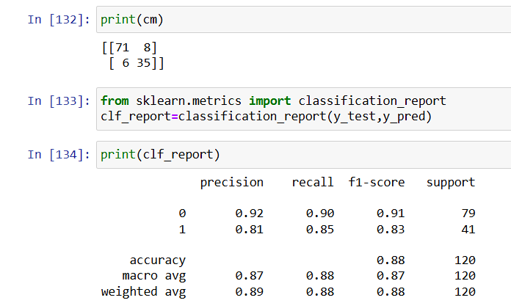

***log_loss :***

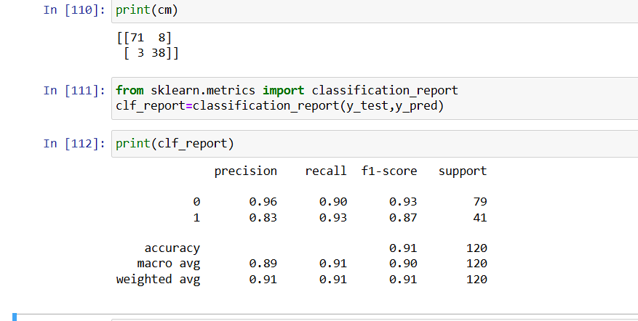

***Entropy:***

